Program No.: 09

**Aim:**

Create a module and access members from a module.

**Topics covered:**

Modules

**Course Outcome**

CO2 : Implement basic Data Structures in Python

**Case Studies:**

***Case Study 01:***

***Problem Statement:***

Python program to print the fibonacci series upto n using modules

***Problem Solution:***

1. Take a number as input.

2. Create a module with name fib.py.

3. In fib.py write the logic for printing fibonacci series.

4. Logic is, take a=0 and b=1.

5. If n is 0 print a only.

6. Otherwise print a , b and c=a+b.

7. While c is less than n print c, a=b, b=c, c=a+b.

8. Stop.

***Program/Source Code:***

"""

Python script to find Fibonacci series using the modules.

"""

Case Study : 01

File Name : Cs1.py

Topic : MODULES IN PYTHON

"""

#importing module

from fib import fib

#Taking input

n=int(input("Enter upto which u want to print fibonacci series:"))

fib(n)

#Fib.py

#Defining fib function

def fib(n):

a=0

b=1

if n==1:

print(a)

elif n==2:

print(a,b,sep="")

elif n>2:

print(a,b,sep="",end="")

n=n-2

for i in range(n):

fib=a+b

print("",fib,sep="",end="")

a=b

b=fib

***Program Explanation:***

1. Take a number as input.

2. Create a module with name fib.py.

3. In fib.py write the logic for printing fibonacci series.

4. Logic is, take a=0 and b=1.

5. If n is 0 print a only.

6. Otherwise print a , b and c=a+b.

7. While c is less than n print c, a=b, b=c, c=a+b.

8. Stop

.

***Runtime Test Cases:***

1. Enter upto which u want to print fibonacci series:4

0

1

1

2

3

1. Enter upto which u want to print fibonacci series:8

0

1

1

2

3

5

8

**Output:**

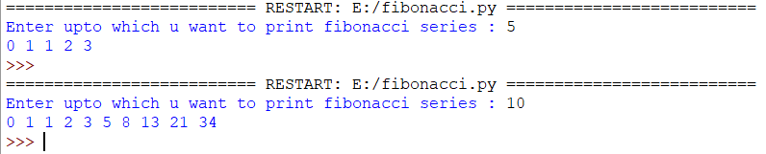

**Result:**

Creating a module and access members from a module is done successfully.